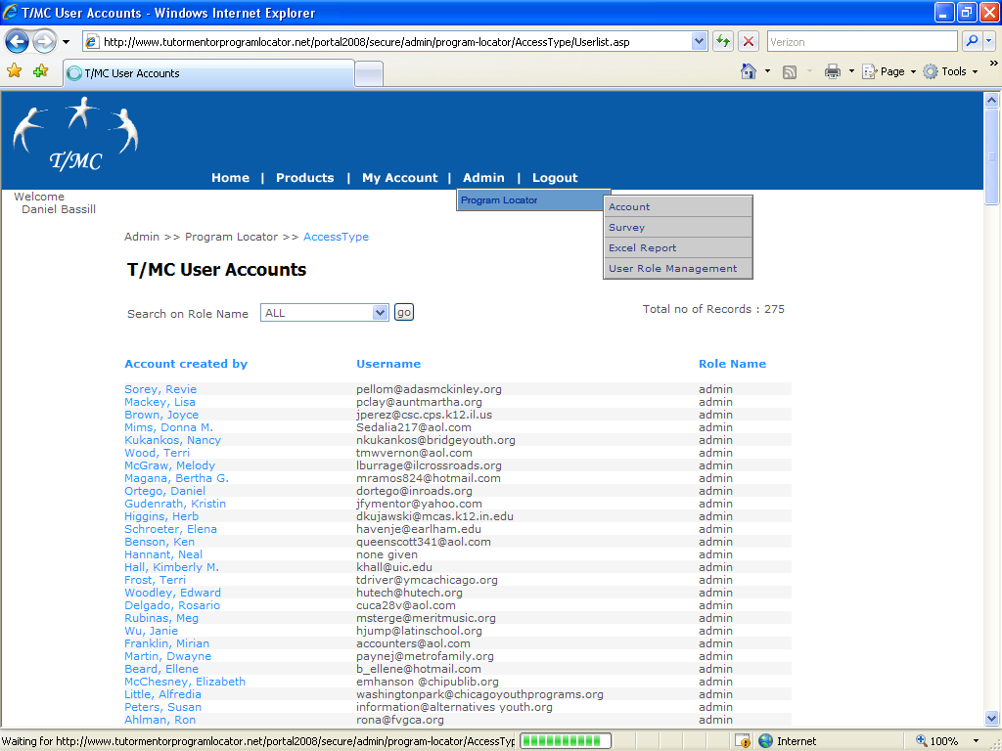
USER ROLE MANAGEMENT – New web link
- Within ADMIN menu, Program Locator option, we have new sub-menu “User Role Management” – Click the sub-menu and the control will take you to new page.
- This page have the list of T/MC users and roles
http://www.tutormentorprogramlocator.net/portal2008/secure/admin/program-locator/AccessType/Userlist.asp
- Click on the Account created by (blue color hyperlinks)
http://www.tutormentorprogramlocator.net/portal2008/secure/admin/program-locator/AccessType/edit-Access.asp?lgnid=1
Control will be take to this new link/page
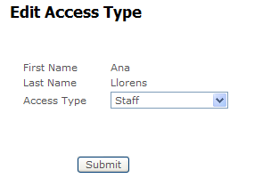
- Change the Role name (Access Type) dropdown field and click SUBMIT button.
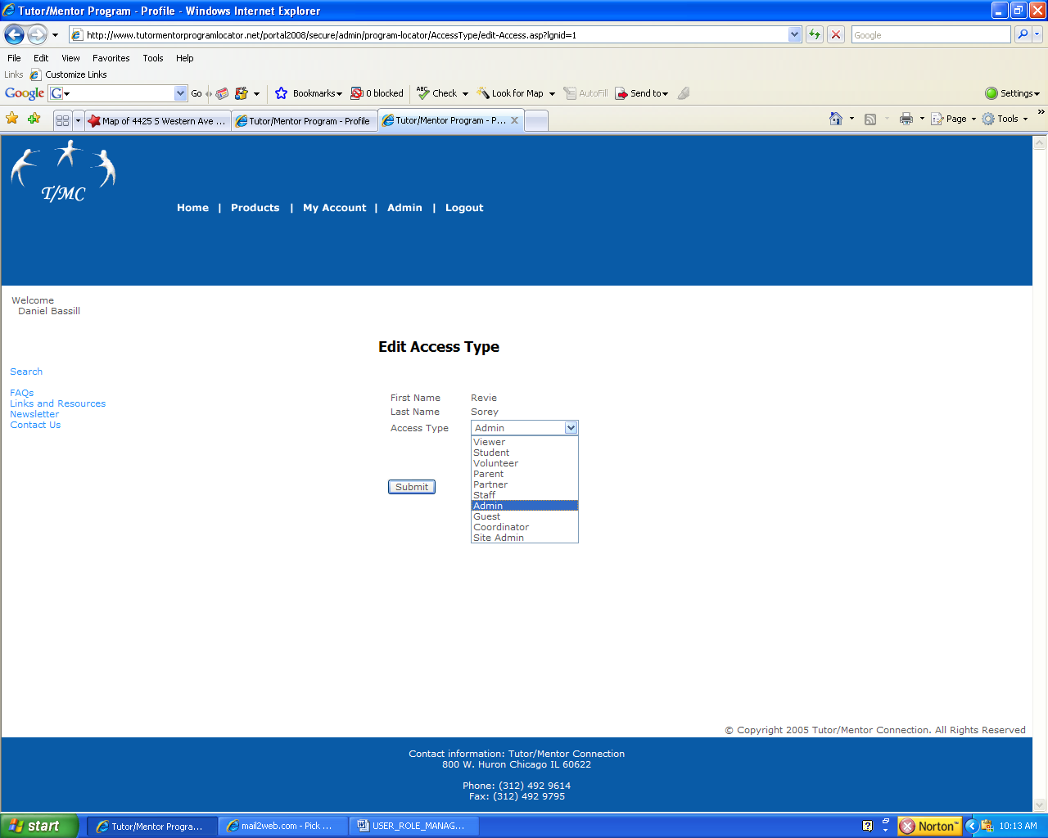

5) Access Types -
a) Network admin (dan, ganesh)
b) Network Admin Staff (able to add, edit, and make any changes, to any survey, access excel file, etc. Can not delete files)
c) Survey Contact - the person and email listed on page one of the survey - has access and can edit that account only
d) Survey Admin - a second person who can edit information for specific survey

Make sure that what you are setting up ties the survey contact and admin person to a specific survey.
In the initial set up, make sure the contact people and admin people are correctly coded so I don’t have to go through 500 records to re-code them as contact or admin.

6) In the program locator files you can see surveys that were entered by myself or my staff, and they show the contact name as dan bassill. We can’t figure out how to change that to the name of the survey contact (c) or survey admin (d). Can you look at that?

